First: Go to “redshelf.com” in your preferred browser. This will take you to the website that the book is located in.

Select the Log in Button that is located in the rightmost corner. See picture below and locate the red circle to find the Log in button.Select the “Forgot Password Option that is located under the blue Log In Button on the left-hand side. See the red circle below to locate the “Forgot Password” Button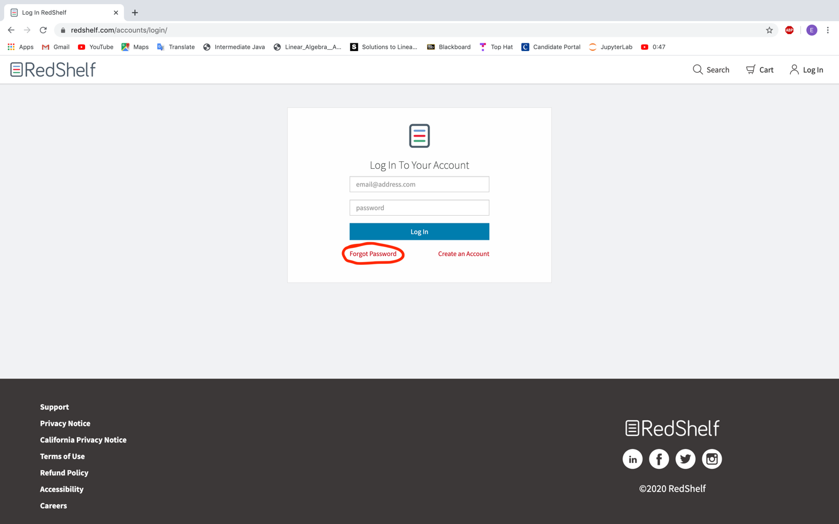Once you reach this page, enter the University-given email (ending in “@pitt.edu”) into the box provided above the “request reset” button. See image below to locate the box. Select the “Request Reset” button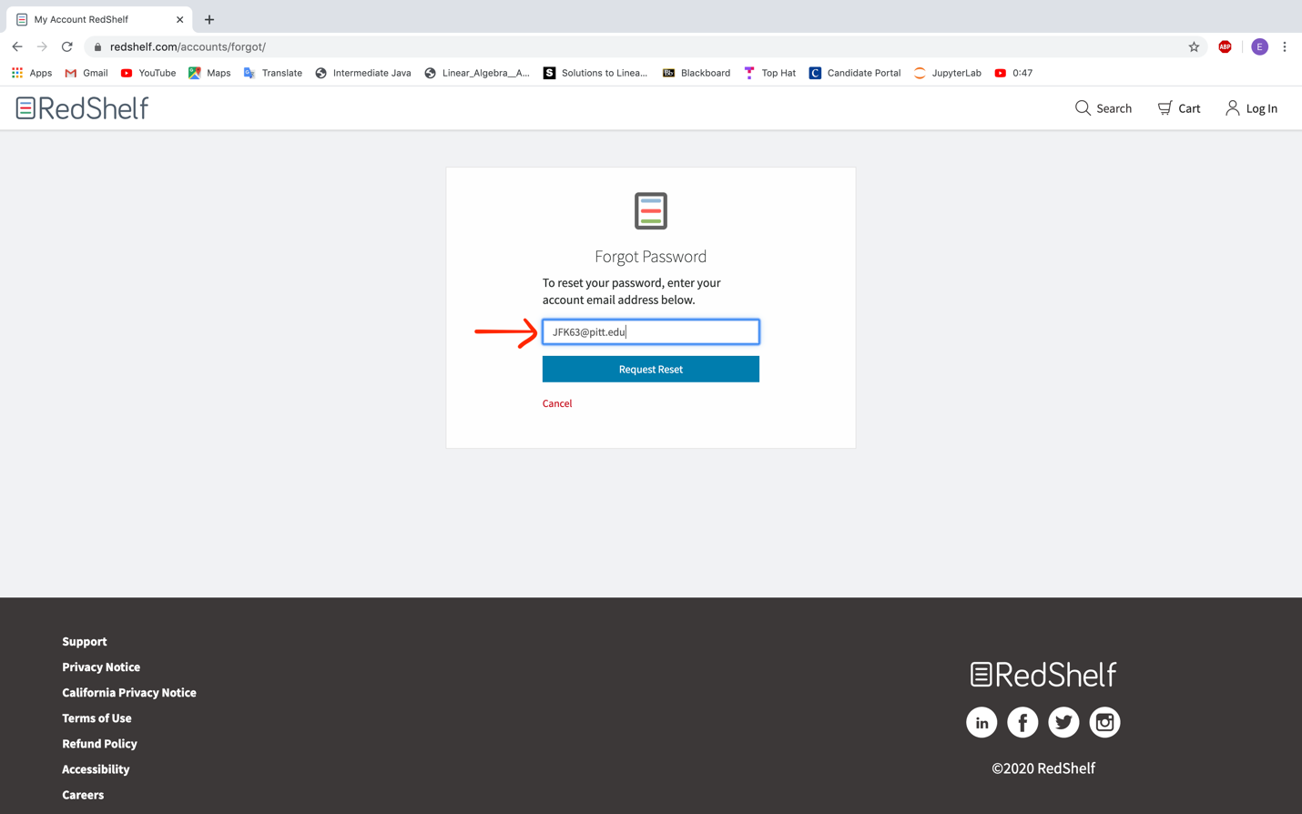The image below shows the confirmation message that you will see once the request has been successfully sent. See the image below to view the message you will see for confirmation.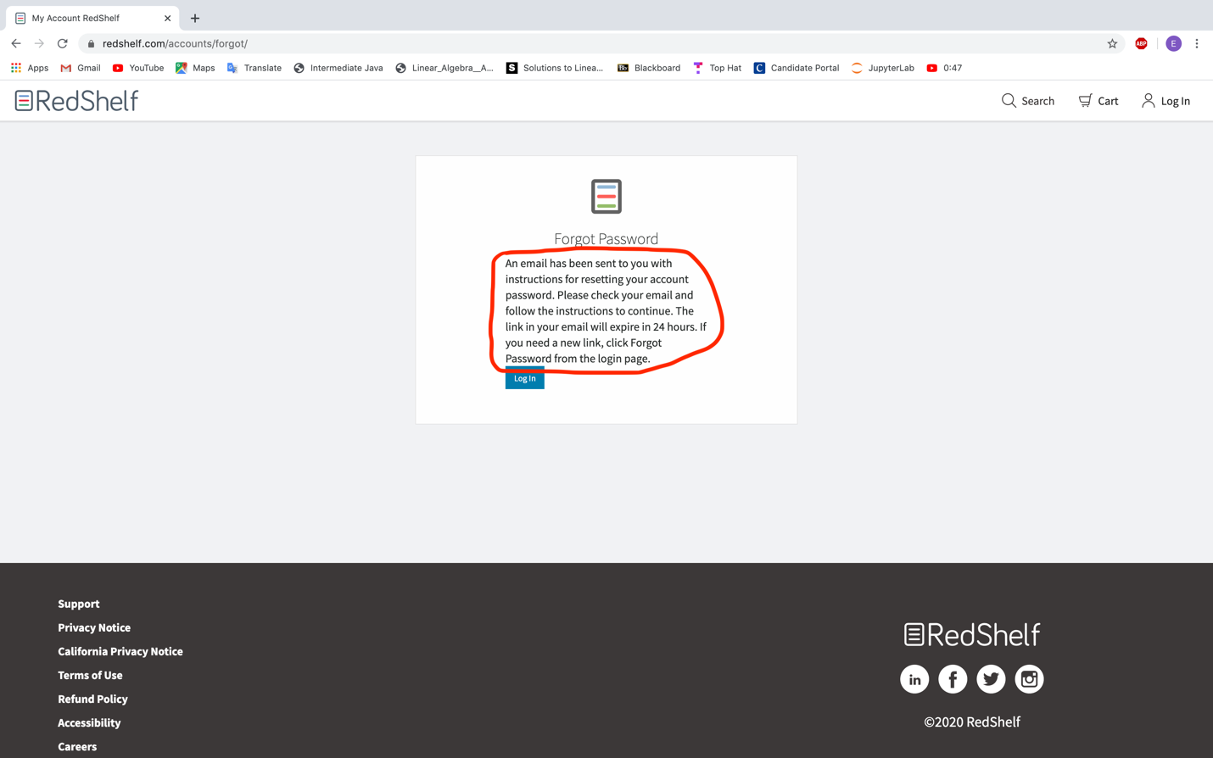Go to your “Pitt” email and wait for the email to be received from RedShelf. The subject will be “Reset your RedShelf password” and it will be sent from donotreply@redshelf.com. Select the link provided to be redirected to a page where you can set your password. See image below for an example of the email you will receive.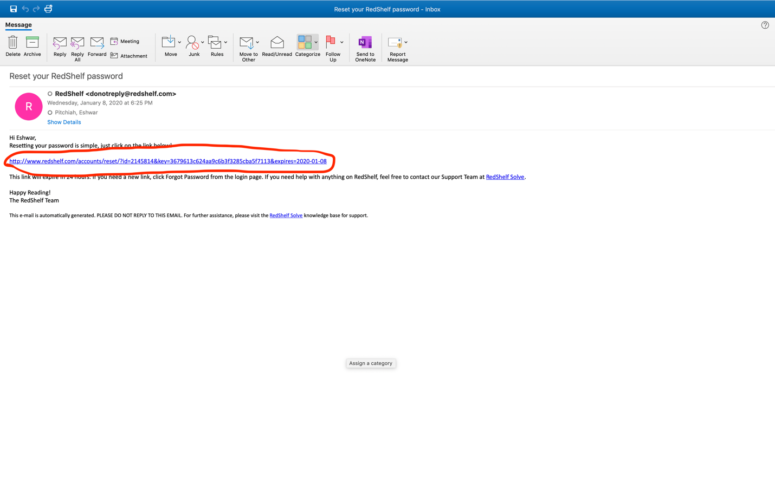Enter your password in the box adjacent to the “Password:” message. Then re-enter your password in the box adjacent to the “Confirm Password:” message. See image below to see example of where to enter password. Once you are satisfied with your password, select the blue “Reset Password” button.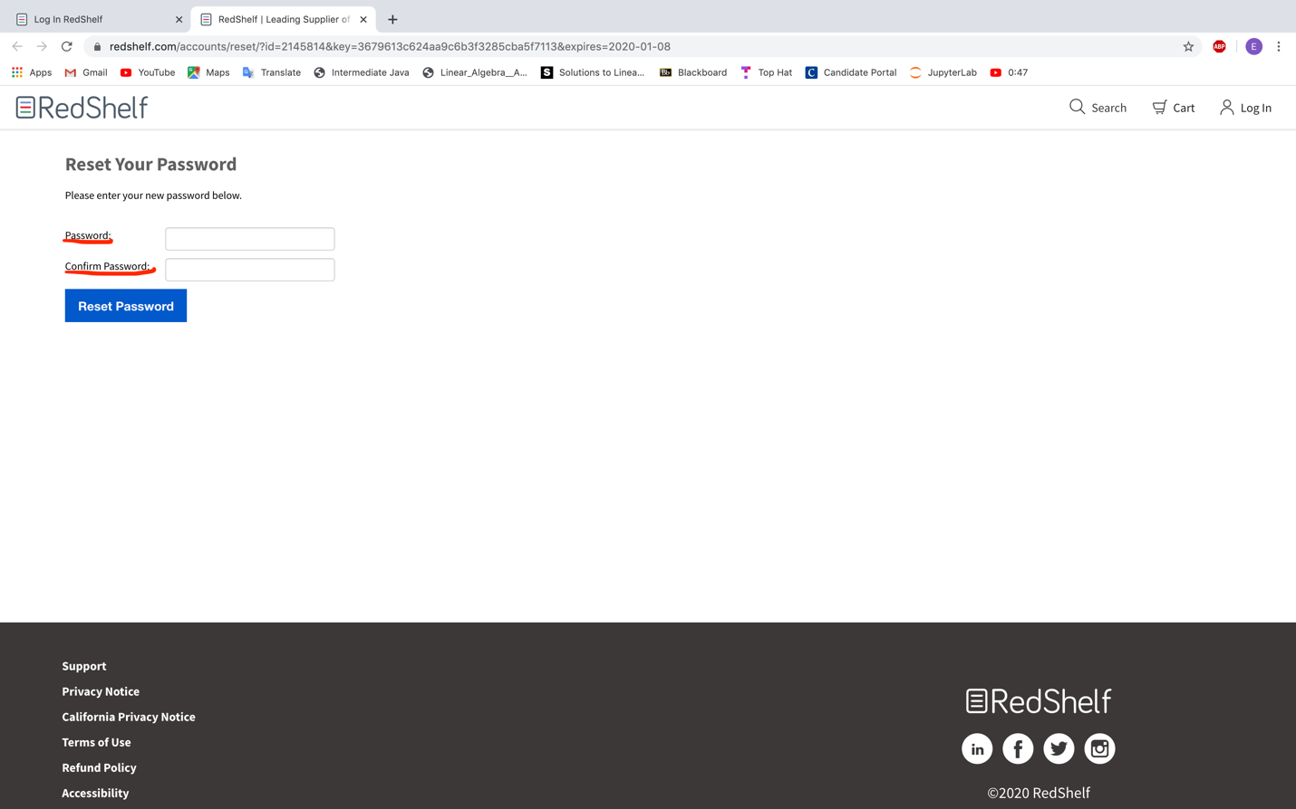The image below shows the confirmation message once your password has been reset successfully. Once you have reached this page, select the “Log In” button to go back to the Log In page. See image below to locate the Log In Button on the top right corner of the page.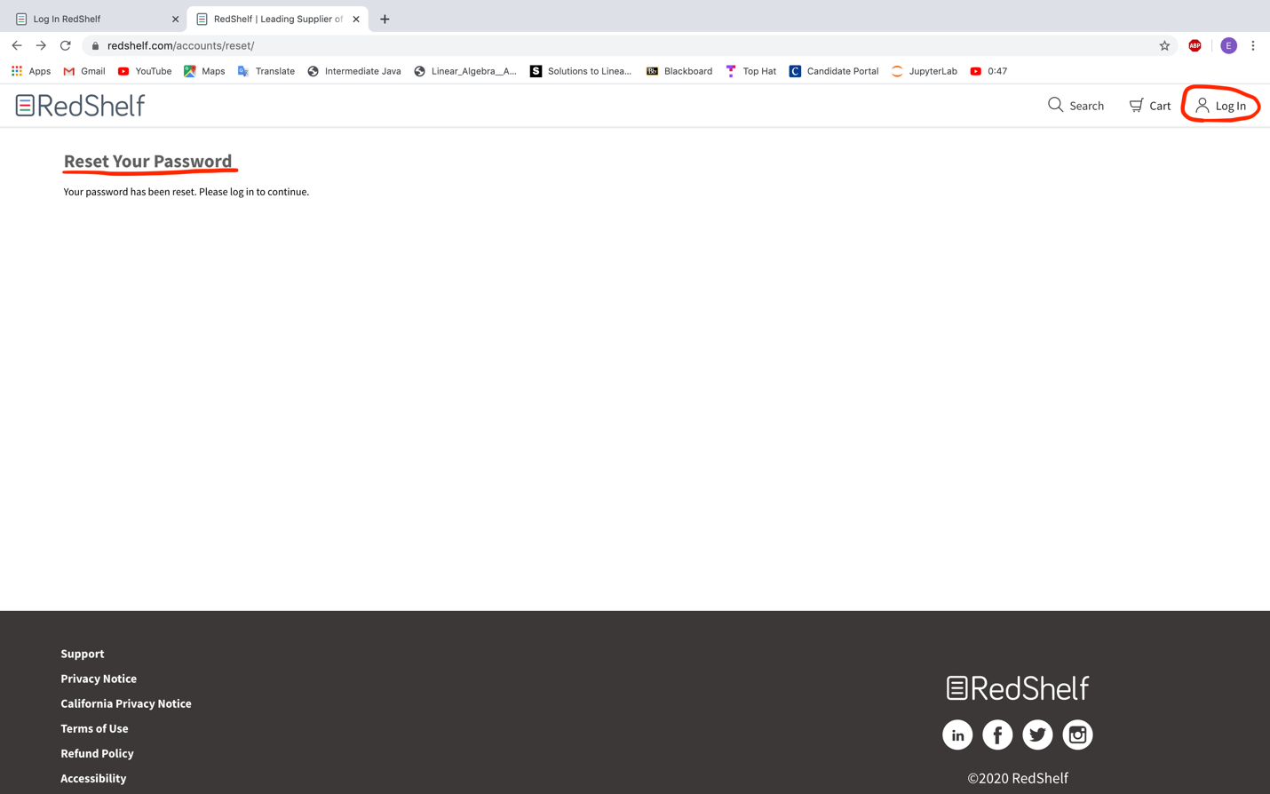Once you have reached this page, enter your “Pitt” email into the email box and the Password you just created into the password box. See image below to locate the email and password box. Once you have entered the correct email and password, select the blue “Log In” button. 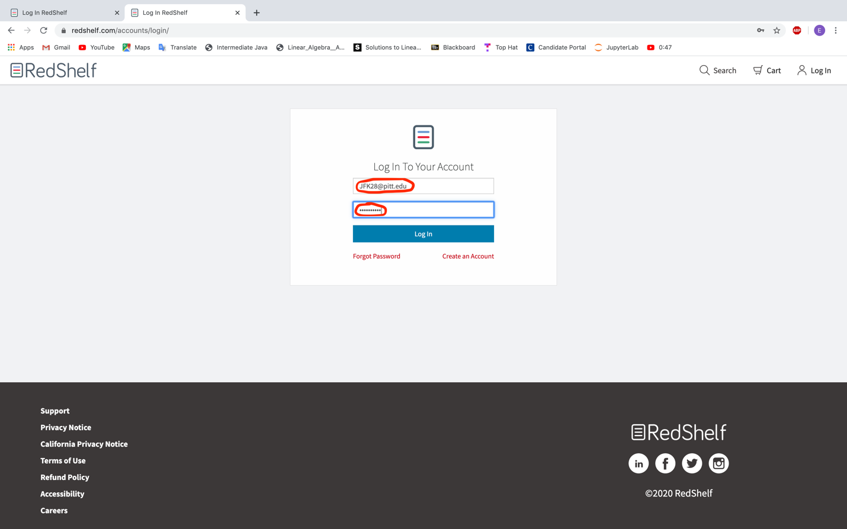The image below shows what the page you will see once you have successfully logged into the RedShelf website. Locate the “Data Structures and Abstractions with Java(POD File)” textbook. Select the Green “Start Reading” button to open your textbook. See image below to view where the green “Start Reading” button. Congratulations! You have reached your textbook! 