How to access CS 445 Textbook:

1. Go to <redshelf.com> and click the **Log In** button



1. Type in Pitt email in the box with [email@address.com](mailto:email@address.com) box then click Forgot Password

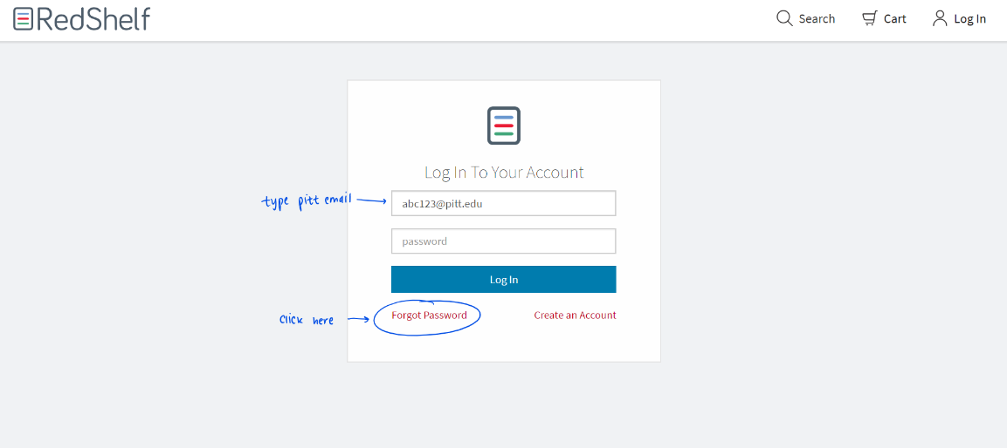

1. Enter email address is the box provided to send the reset email – you will see the confirmation that the email has been sent

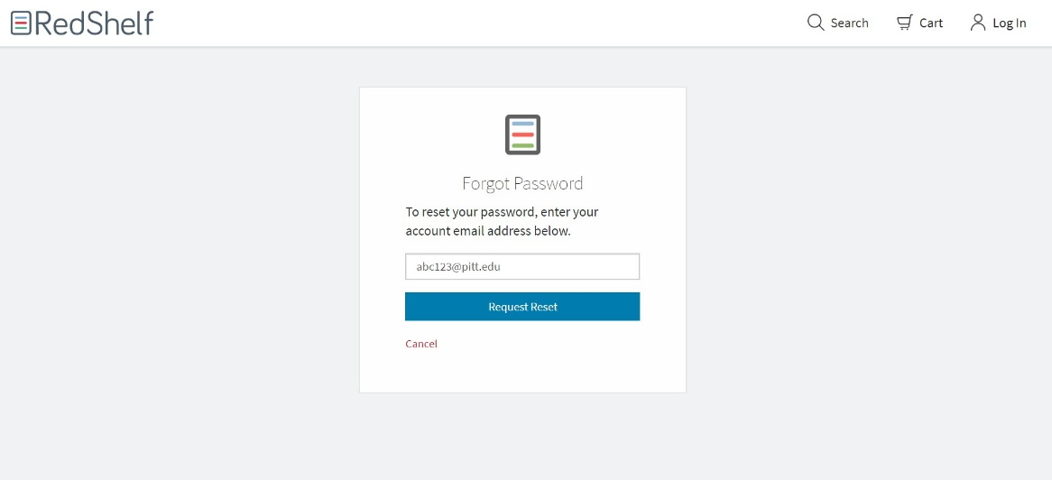

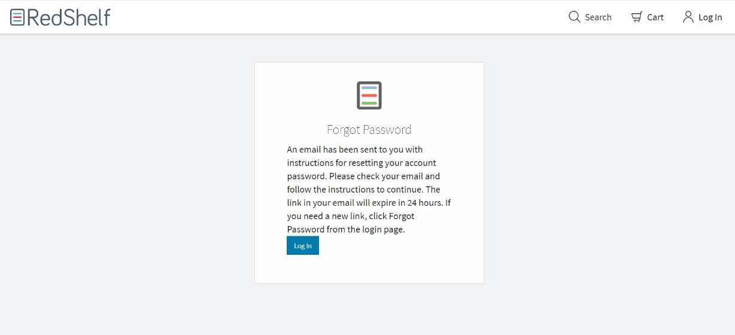

1. Go to Pitt email account and look for the reset password email from redshelf (may be in clutter folder)

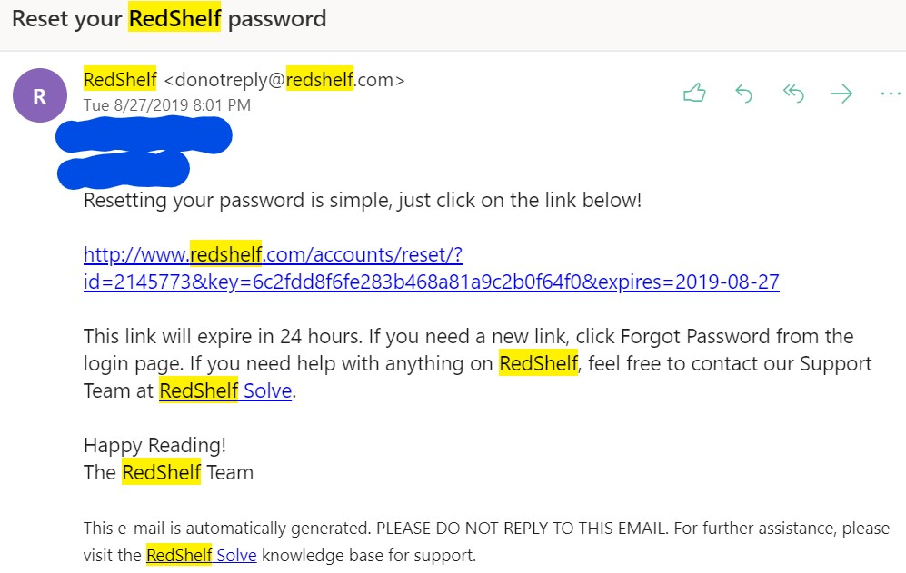

1. Click on reset link in the email
2. 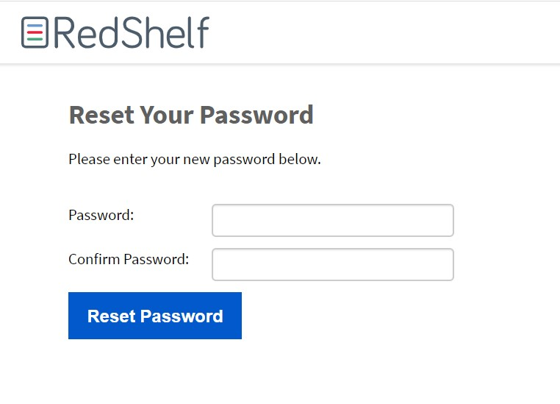Link will lead to a new page where you input a new password and confirm it – will see a confirmation notice

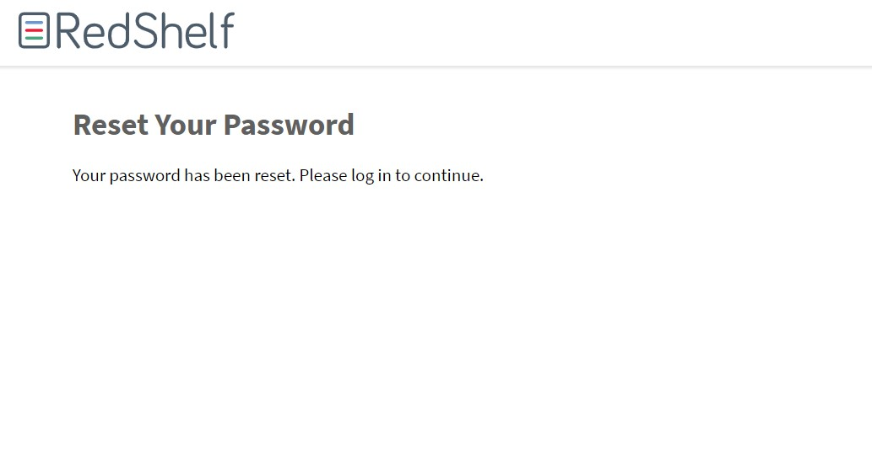

1. Log in with Pitt email address and new password

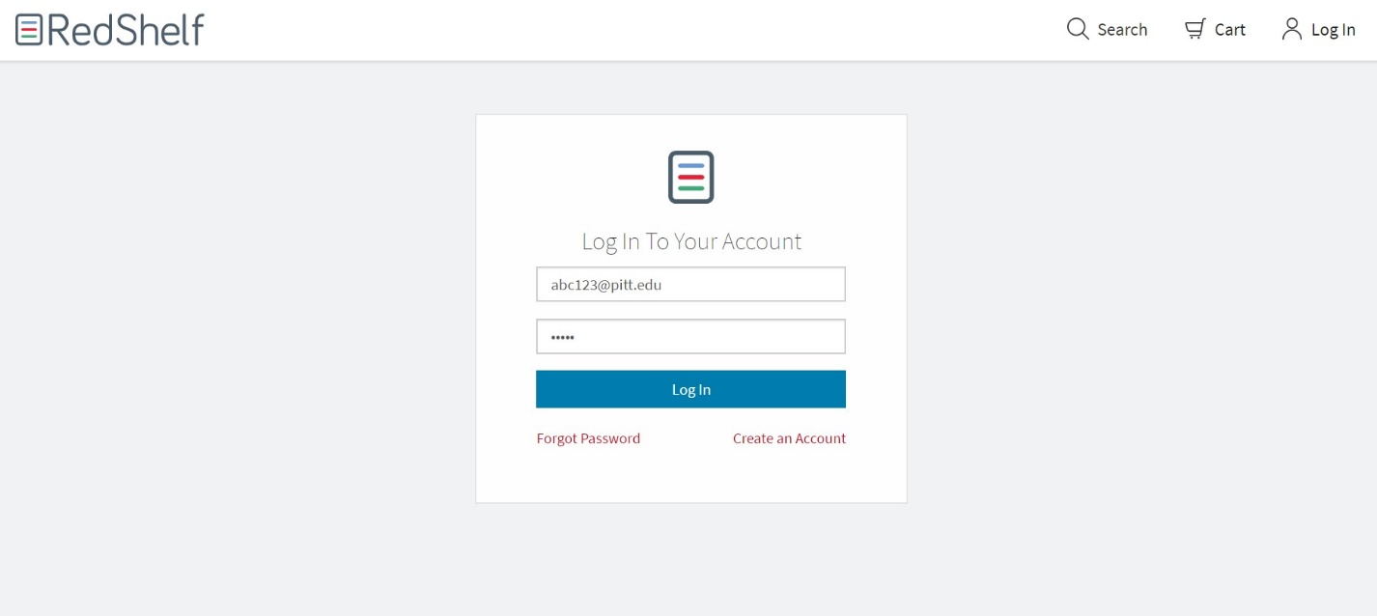

1. Find Textbook and click green Start Reading button

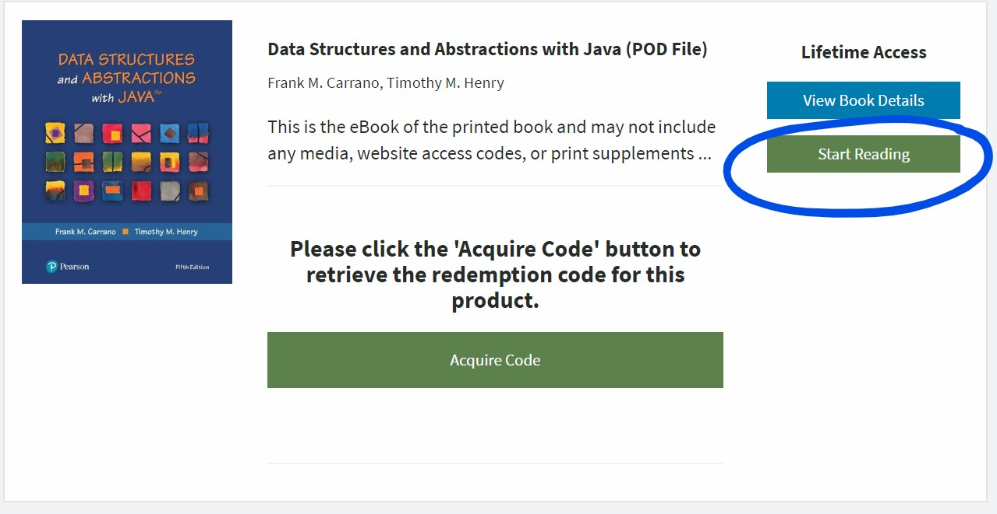

1. You can now browse the textbook

